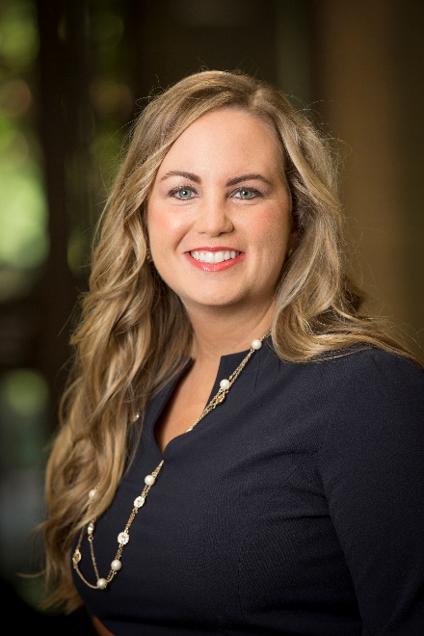

Kristie Edelen

Kristie Edelen, PharmD, DABAT started working at the Oklahoma Center for Poison and Drug Information (OCPDI) as a pharmacy student in 2008 and graduated from the University Of Oklahoma College Of Pharmacy in 2011. Upon graduation she knew she had two passions: toxicology and pediatrics. She completed a PGY-1 Pharmacy Practice Residency at the Children’s Hospital at Saint Francis in Tulsa, Oklahoma in June of 2012. After her residency she went back to the Oklahoma poison center, where she currently gets to use her knowledge of both pediatric medicine and toxicology. Kristie became a Diplomate of the American Board of Applied Toxicology in November 2018. She has been with the OCPDI for almost 8 years now, and she gets to do a job every day that she truly loves with people that make the job enjoyable.

