Dear ,

We are very excited that you have agreed to speak at the (RSS Title). Below please find guidelines that are from the Accreditation Council for Continuing Medical Education (ACCME) and the OU College of Medicine, Office of Continuing Professional Development (CPD office), the entity providing the AMA PRA Category 1 Credits TM for this conference. You will also be receiving an e-mail from the CPD office, explaining how to complete your disclosure form and upload a CV, a short bio and a photo. The bio and photo will be used on the CPD website to provide participants more information about you. Please have these items completed by (Date: 1 week before talk).

Items needed to CME Office 1 week before the talk
- Disclosure Form
- CV
- Brief Bio
- Photo

As you begin to prepare your presentation, please keep in mind that, as an accredited provider, CPD office, requires all speakers to be aware of their role and responsibilities. Your role is very important to the goal of an unbiased educational activity, and we appreciate your time and attention to our requirements. If you have any questions, please call the CPD office at (405) 271-2350.

I have attached a PowerPoint template for you to use for your presentation. Please e-mail your final presentations directly to me by 1 week before your presentation. This will allow enough time for us to review content for the items below and send it on to the CPD office for final approval.

Items needed to me, (course contact email), 1 week before presentation
- FINAL Presentation w/disclosure slide (see checklist below)

Please use the following checklist to ensure your FINAL presentation meets the requirements of the CPD office. This list will be used to review your presentation. You will be asked to fix anything that does not meet these requirements.

Presentation Checklist

- Speakers must begin their presentation with a disclosure slide that includes the following:
- This statement: Under Accreditation Council for Continuing Medical Education (ACCME) guidelines, disclosure must be made regarding financial relationships with commercial interests within the last 12 months;
- The speaker’s name
- All relevant commercial interests, including the name of the commercial interest, the role the speaker has with the commercial interest and what type of financial interest is involved. If there is no commercial support, the disclosure slide must include the following statement: I have no relevant financial relationships or affiliations with commercial interests to disclose.

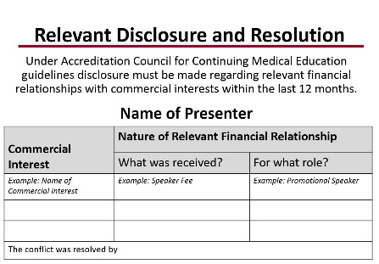

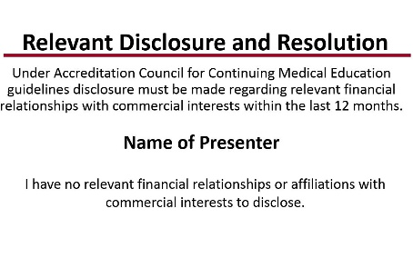

- While the slide is present, speakers must verbally disclose the information on the slide.

- All the recommendations involving clinical medicine in a CME activity must be based on evidence that is accepted within the profession of medicine as adequate justification for their indications and contraindications in the care of patients.

- All scientific research referred to, reported, or used in CME in support or justification of a patient care recommendation must conform to the generally accepted standards of experimental design, data collection, and analysis.

- It is the responsibility of the presenter to obtain written permission for print inclusion of material including photographs that is under copyright (©) protection. You must include the correspondence showing you have received permission.

- Presentations must be free of commercial bias for or against any product. Speakers must give a balanced view of therapeutic options. Use of generic names will contribute to this impartiality.

- If CME educational material or content includes trade names, trade names from several companies should be used where available, not just trade names from a single company.

- Please check your slides, abstracts and handouts to ensure they do not include any advertising, logos, trade names, or product-group messages.

- Make certain your presentation/materials do not include individually identifiable health information, in accordance with the Health Insurance Portability and Accountability Act (HIPAA), unless you have appropriate authorization. You must provide such authorization upon request of the CPD Office.

- If your presentation contains discussion of off-label or investigational uses of drugs or medical devices, the audience must be advised/informed. An off-label slide must be added to the presentation.

- When using acronyms and abbreviations, please provide the definition on the first reference.
Example: ACCME (Accreditation Council for Continuing Medical Education)

If you have any questions, please do not hesitate to contact me.

Course Contact Name
Title
Dept.
Address
Phone: 405-271-xxxx Ext. xxxxx
Fax: 405-271- xxxx

