University of Oklahoma Health Sciences Center
Regularly Scheduled Series
Course No. 25D31
Thursday, March 6, 2025
7:15am - 8:00am Central Time

Join Zoom Meeting
https://oklahoma.zoom.us/j/93839121647?pwd=dihdzn4WObpdWClaS7TFcACq3srk7U.1
Meeting ID: 938 3912 1647
Passcode: 12345678

Ultrasound Imaging Artifacts
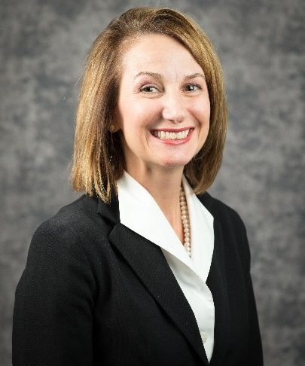
Presented by
Carol Mitchell, PhD, ACS, RDMS, RDCS, RVT, RT(R), FASE, FSDMS
University of Wisconsin – Madison
School of Medicine and Public Health
Department of Medicine
Madison, Wisconsin

Learning Objectives: Upon completion of this session, participants will improve their competence and performance by being able to:

- List common artifacts seen while performing cardiac ultrasound.
- Describe methods for eliminating artifacts.
- Recognize imaging artifacts as seen on cardiac ultrasound images.

Accreditation Statement: The University of Oklahoma College of Medicine is accredited by the Accreditation Council for Continuing Medical Education (ACCME) to provide continuing medical education for physicians.

The University of Oklahoma College of Medicine designates this live activity for a maximum of .75 AMA PRA Category 1 Credit™. Physicians should claim only the credit commensurate with the extent of their participation in the activity.

ANCC Accreditation Statement: OU Medicine, Inc. is accredited with distinction as a provider of nursing continuing professional development by the American Nurses Credentialing Center’s Commission on Accreditation.
.75 CNE contact hours will be awarded for meeting the following criteria: 90% attendance of conference, completion and submission of evaluation form.
This educational activity does not include any content that relates to the products and/or services of a commercial interest that would create a conflict of interest.

Mitigation Statement: The University of Oklahoma College of Medicine, Office of Continuing Professional Development has reviewed this activity’s speaker and planner disclosures and has mitigated all relevant financial relationships with ineligible companies, if applicable.

The University of Oklahoma is an equal opportunity institution. www.ou.edu/eoo

Accommodation Statement: For accommodations, please contact Debi Green at debi-green@ouhsc.edu /405-206-3767 or Pam Tomey at pam-tomey@ouhsc.edu /405-271-4742, ext. 44745.

Disclaimer Statement: Statements, opinions and results of studies contained in the program are those of the presenters and authors and do not reflect the policy or position of the Board of Regents of the University of Oklahoma (“OU”) nor does OU provide any warranty as to their accuracy or reliability.

Disclosure & Mitigation Report
Role(s) | First Name | Last Name | Ineligible Company |  | Nature of the Financial Relationship
Planning Committee | Lauren | Daniel, MSN, RN | I have no financial relationships or affiliations with ineligible companies to disclose.
Planning Committee/Co-Course Director | Usman | Baber, MD | Amgen USA; AstraZeneca Pharmaceuticals LP; Boston Scientific; Abbot | Honoraria
Course Contact | Candice | Edwards | I have no financial relationships or affiliations with ineligible companies to disclose.
Course Contact | Debi L. | Green | I have no financial relationships or affiliations with ineligible companies to disclose.
Course Director/Moderator | C.A. | Sivaram, MD | I have no financial relationships or affiliations with ineligible companies to disclose.
Presenter | Carol | Mitchell, PhD, ACS, RDMS, RDCS, RVT, RT(R), FASE, FSDMS | Elsevier |  |  | Honoraria
 |  |  | W.L. Gore & Associates |  |  | Grant/research support

