**If you have an OUHSC email address, please read the information in the red boxes.**

**Step 1**: Go to [**https://ouhsc.cloud-cme.com**](https://ouhsc.cloud-cme.com/). Click **Sign In**.

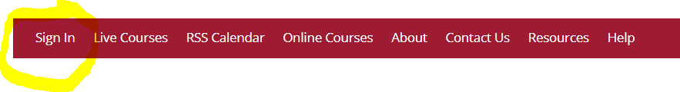

**OUHSC Employees:   
If you have an OUHSC e-mail address, you may already have a CloudCME account:**

Click on **Use this option if you have an OUHSC e-mail address**

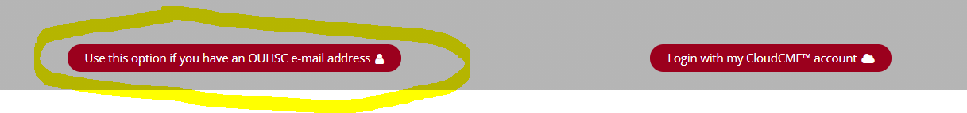

Enter your OUHSC user name and password

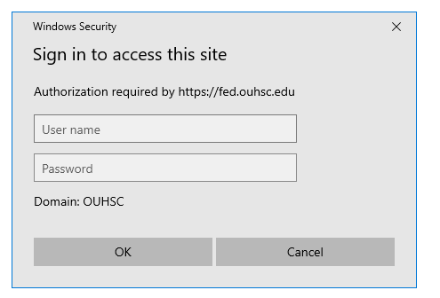

**If your account is not found, proceed to Step 2 below**

**Step 2**: Click **Login with my CloudCME account**

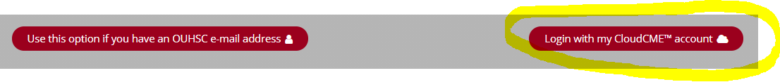

**Step 3:** Click the **Create New Account** button.

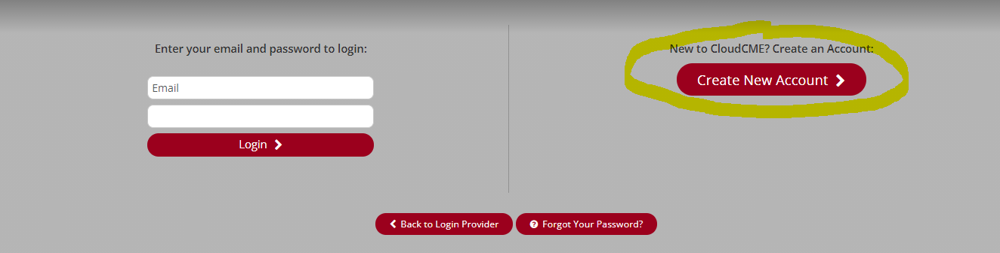

**Step 4**: Enter your information and check the User Agreement checkbox at the bottom. All fields are required. Click the **Create Account** button.

**OUHSC EMPLOYEES:** If you have an OUHSC email address, please enter your OUHSC password.

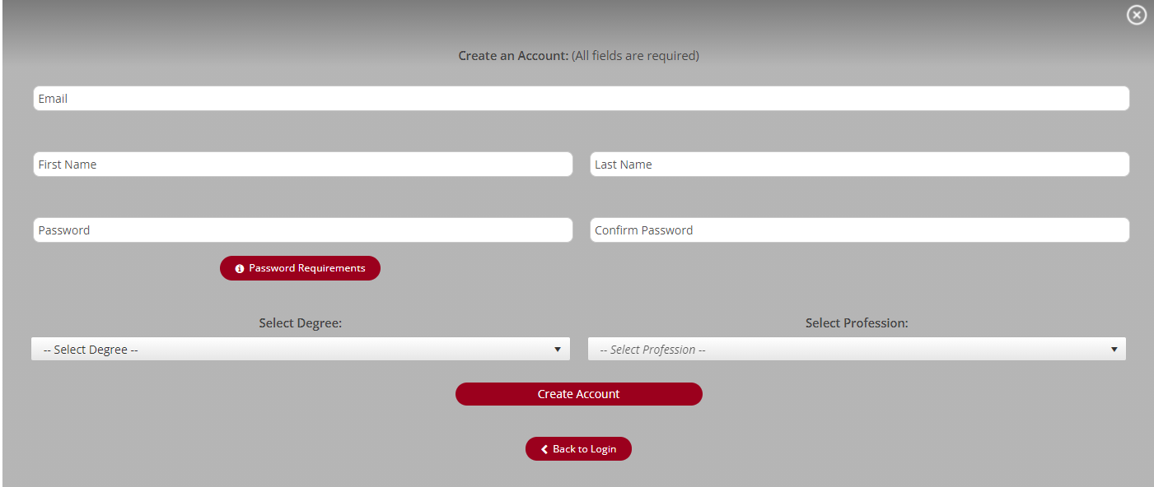

**OUHSC EMPLOYEES:** When you log into CloudCME, you will select the option, Use this option if you have an OUHSC e-mail address and will enter your **OUHSC user name and password**.

Once you have created your account, log in and update your profile:

1. Go to [**https://ouhsc.cloud-cme.com**](https://ouhsc.cloud-cme.com/). Click **Sign In  
 If you have an OUHSC email address:** Click on **Use this option is you have an OUHSC or DMEI e-mail address** and enter your OUHSC or DMEI user name and password.   
 **If you do NOT have an OUHSC or DMEI email address:** Click on **Login with my CloudCME account** and enter your email address and password.

2. Click on **My CME**  
3. Click on **Profile**

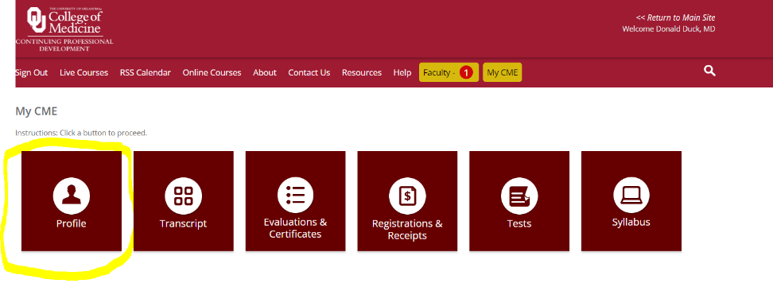

Any fields that are highlighted in red must be completed.

